MEMORANDUM OF UNDERSTANDING

BETWEEN

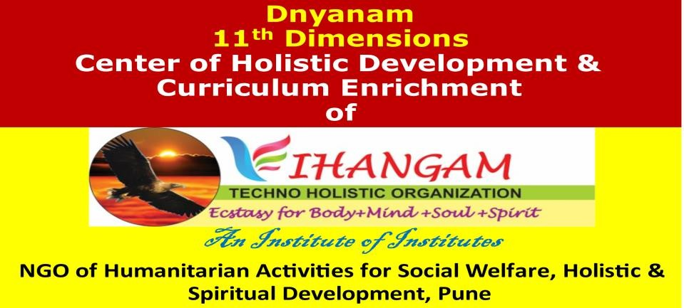

AND

-------------------------------------------------

This MOU details the modalities and general conditions regarding collaboration between Vihangam Techno Holistic Organization, Pune (Here after will be refereed as VTHO) and …………………….

Date: …………

Memorandum of Understanding (MoU)
I. OBJECTIVES OF THE MoU

Engineering education is transforming. National education policy 2020 has focused on imparting holistic education. As per the world economic survey, demands of employment skills is changing. Higher education has to collaborate with different organizations to sustain in those transformations. These collaborations will also facilitate for grooming engineering students with appropriate technical skill set and also for their holistic development.
II. Objectives of Vihangam Techno Holistic Organization (VTHO)

Spirituality, religious coping, and religious belief are better predictors of happiness and quality of life. Therefore, our aim of is to foster ancient knowledge, culture, science and values with advanced technology to build mentally, physically super powered, vigorous, bright, talented and blissful human beings across the Globe to fetch body +Mind +soul spirit level happiness for the human life and also to serve for development and uplifting of mankind. We have seven centers namely Dynanam, Bodhanam, Dhyanam, Arogyam, Shodhanam, Prasadam and Kalyanam. Our first center
Dnyanam is meant for executing collaborative activities for educational institutes with whom we establish MoU.
III. Objectives of Dnyanum Center of VTHO

- Dnyanam: 11th Dimensions: Center for Holistic Development/ Curriculum Enrichment & Execution (for multi-dimensional development):
Through our Dnyanam center of holistic development/Curriculum Enrichment & Execution we collaborate with different higher educational institutes to assist them in grooming multidimensional, mentally strong and well-balanced personalities of students including their behavior, attitude, and values. Our highly specialized, well known, reputed experts’ team in the respective field have designed following value-added certificate courses to enrich conventional curriculum for holistic and all-round development of students as well as teachers. Each course is developed considering age groups, type of institutes and educational programme being imparted. As per the need of institute’s our expert’s team will execute very well chalked out following or similar kind of short programmes & certificate courses finely tuned with your day-to-day schedule.

  - All topics related to institutes quality improvement & grading like NBA/NAAC/NEP /Pedagogy/ teaching-learning process and quality improvement
  - Personality Development
  - Leadership Skill Development
  - Goal Setting and Coaching for Career Growth
  - Personal Action Planning for Professional Development
  - Developing Team Building Skills and Spirits
  - Relaxation & Meditation Techniques
  - Spiritual and Ancient Techniques for Successful Life
  - Lifelong & Self Learning Skill Development
  - Counselling/Mentoring/Coaching
  - Designed & Creative Thinking
  - Innovative Tools & Techniques for Enhancing Learning Outcomes
  - Adopting Advanced Online Pedagogy/teaching methodology
  - Teaching methodologies for Improving students listening, reading, and writing skills
  - Methodologies for improving student’s concentration and learning outcome
  - Brain developments
  - Study techniques
  - Project based learning
  - Active learning/Collaborative learning
  - Student Centric learning/Experiential learning
  - Neuro linguistic programming (NLP)
  - Positive thinking/Holistic diet
  - Physical, mental & psychological health
  - Career Counselling & Advancement
  - Ethics, Values & Prioritization of values for successful life
  - High/Universal human values (UHV) and prioritization
  - Social values & responsibility
  - Time management
  - Stress management
  - Yoga, Pranayama, Omkar sadhana, Breath Techniques for peace building
  - Any other as per the need

IV-A-SCOPE OF THE MoU FOR EDUCATIONAL INSTITUTE (You can select as per your choice)
Vihangam Techno Holistic Organization, Pune (VTHO) and
…………………………… shall encourage associations for carrying out following activities:

- Interactions between the administrators, heads of departments, teaching and non-teaching staff and students for motivating, troubleshooting, increasing performance, curriculum enrichment, modifying, enhancing academic systems, introducing innovative procedures and improving overall quality of education.
- Inspiring/Motivating/Mentoring/counselling/coaching individual faculty, staff and students in the area of personal and professional development
- Organization of expert lectures, conferences, workshops, seminars, faculty development programmes and training porgrammes for overall personal development of administrators, teaching staff, non-teaching staff and students.
- Designing and executing short term certificate and value-added courses for student’s multi- dimensional and holistic development.
- Organizing social drives and spiritual retreat programmes.
- Providing opportunity for employees and students in VTHO programmes of community development
- Visit & One day meditation programme in our Sudarshan Pyramid Paradise for administrators & teachers
- Any other with mutual agreement

IV-B-Scope of Associations with Educational Institutes

- Interactions between the administrators, heads of departments, teaching and non-teaching staff and students for motivating, troubleshooting, increasing performance, curriculum enrichment, modifying, enhancing academic systems, introducing innovative procedures and improving overall quality of education.
- Inspiring/Motivating/Mentoring/counselling/coaching individual faculty, staff and students in the area of personal and professional development
- Organization of expert lectures, conferences, workshops, seminars, faculty development programmes and training porgrammes for overall personal development of administrators, teaching staff, non-teaching staff and students.
- Designing and executing short term certificate and value-added courses for student’s multi- dimensional and holistic development.
- Organizing social drives and spiritual retreat programmes.
- Providing opportunity for employees and students in VTHO programmes of community development
- Any other with mutual agreement
IV-C-Scope of Associations with Industries Under CSR Funding
CSR funds of indutries can be utilized for carrying out activities of Vihangam’s scope & objectives. For value addition to CSR funds mutual associations can be formed for following-
- Training for saftey to workers & staff
- Consultation for factories act
- Ledaership Skill Development
Organizing workshops/trainings on holistic topics listed 27 topics above

V CO-ORDINATION OF THE PROGRAMME
- Courses may run at any mutually convenient modes of online/off line at premises of both the institutes or outside.
- The collaborative programs between VTHO, Pune and ……………. shall be coordinated by a coordination committee appointed by both the Institutes.
- Preparation and publicizing of certificates/catalogs/broachers/news/videos will be done with mutual agreements between VTHO and …………….
- …………….. shall plan 2-4 events per semester for students/faculty/non-teaching staff under this MoU. One event will be totally free and second/alternate event can be organized by taking charges from participants from which speaker’s remuneration can be paid off with suitable donations to VTHO at least once in a semester.

VI EFFECTIVE DATE AND DURATION OF MOU
  - This MoU shall be effective from the date of signing by competent authorities at both ends.
  - The duration of the MoU shall be for a period of one year from the effective date.
  - The MoU may be extended or terminated by any one of party after intimating other.
  - Any clause or article of the MoU may be modified or amended by mutual agreement of both the parties.

IN WITNESS WHEREOF PARTIES HERE TO HAVE ENTERED INTO THIS AGREEMENT EFFECTIVE AS ON THE DATE AND YEAR FIRST WRITTEN ABOVE.

1)

2)

